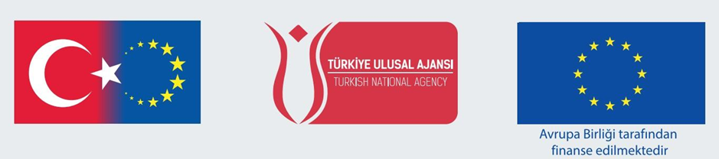The Role of Public–NGO Cooperation in Combating Addiction During Crisis and Disaster Periods: An Evaluation on Youth
Abstract
Crisis and disaster situations significantly affect individuals’ mental health and increase vulnerability to substance use and addictive behaviors, particularly among young people. Psychological trauma, social isolation, economic uncertainty, and disruption of support services act as major risk factors during and after crises. This study examines the role of cooperation between public institutions and non-governmental organizations (NGOs) in combating addiction during crisis and disaster periods. Drawing on recent statistical data and selected European case examples, the article argues that coordinated public–NGO action contributes to improved access to psychosocial support, enhanced rehabilitation outcomes, and greater community resilience. The findings highlight the importance of integrating addiction prevention and mental health strategies into crisis management frameworks.
Keywords: addiction prevention, crisis management, youth, public–NGO cooperation, community resilience
1. Introduction
Crisis and disaster periods represent critical moments that test not only physical infrastructure but also social and psychological resilience. Natural disasters, pandemics, armed conflicts, and economic crises have been shown to exacerbate mental health problems and increase the risk of substance use and addiction-related behaviors (WHO, 2023). Young people, in particular, are disproportionately affected due to developmental vulnerability, disrupted social networks, and limited access to support mechanisms.
Recent evidence suggests that addiction patterns emerging during crises may persist long after the immediate emergency has ended, transforming short-term risks into long-term public health challenges (EMCDDA, 2023). In this context, traditional, institution-centered responses are often insufficient. Instead, collaborative governance models that involve both public authorities and civil society actors have gained increasing attention.
This article explores how public–NGO cooperation contributes to effective addiction prevention and intervention during crisis and disaster periods, with a particular focus on youth-oriented and community-based approaches.
2. Methods
This study adopts a qualitative and descriptive approach based on secondary data analysis. Data sources include recent reports published by international organizations such as the World Health Organization (WHO), the European Monitoring Centre for Drugs and Drug Addiction (EMCDDA), the Organisation for Economic Co-operation and Development (OECD), and UNICEF.
In addition, selected European case studies were reviewed to illustrate how public–NGO collaboration functions in practice during and after crises. The analysis focuses on policy frameworks, intervention models, and reported outcomes related to addiction prevention and psychosocial support.
3. Results
3.1. Crisis Contexts and Addiction Risk
According to the WHO (2023), the prevalence of mental health disorders can increase by two to three times in emergency settings. EMCDDA data indicate that following the COVID-19 pandemic, several European countries reported:
- increased alcohol consumption among young adults (up to 20% in some contexts),
- higher rates of substance use linked to anxiety and depression, and
- reduced continuity of rehabilitation and support services (EMCDDA, 2023).
These findings confirm that crisis periods amplify existing vulnerabilities and create new pathways toward addiction.

3.2. Impact of Public–NGO Cooperation
Evidence from OECD (2022) demonstrates that countries with established public–civil society partnerships achieved:
- up to 40% higher access to psychosocial support services, and
- significantly improved continuity of care in post-crisis phases.
NGOs play a complementary role by providing flexible, community-based interventions, while public institutions ensure scale, legitimacy, and long-term sustainability.
3.3. Case Examples
Finland:
A public–NGO partnership focusing on youth mental health and online counseling resulted in a 25% reduction in risky alcohol use and a 60% increase in voluntary help-seeking among young people (Finnish Institute for Health and Welfare, 2022).
Italy:
Following major earthquakes, community-based rehabilitation centers jointly managed by local authorities and NGOs reduced the demand for clinical addiction treatment by approximately 30%, highlighting the preventive potential of early psychosocial interventions (EMCDDA, 2022).
4. Discussion
The findings indicate that addiction during crisis periods should be understood as a multidimensional phenomenon influenced by trauma, social disconnection, and systemic gaps in service provision. Public–NGO cooperation offers a practical framework for addressing these challenges by combining institutional capacity with community trust and accessibility.
For young people, trauma-informed and peer-supported approaches appear particularly effective. Integrating such models into national crisis and disaster preparedness plans can significantly enhance societal resilience and reduce long-term addiction-related harms.
5. Conclusion
Crisis and disaster situations intensify addiction risks, especially among young populations. However, these risks are not inevitable. Coordinated action between public institutions and NGOs enables more responsive, inclusive, and sustainable interventions. Framing addiction prevention as a core component of crisis management is essential for building resilient societies capable of recovering from both immediate and long-term impacts of crises.
References
- EMCDDA. (2022). Impact of disasters on substance use patterns. European Monitoring Centre for Drugs and Drug Addiction.
- EMCDDA. (2023). European Drug Report 2023.
- OECD. (2022). Building resilience through public–civil society partnerships.
- UNICEF. (2023). Youth mental health in humanitarian crises.
- WHO. (2023). Mental health in emergencies. World Health Organization.
- Finnish Institute for Health and Welfare. (2022). Evaluation of youth psychosocial support programmes.

